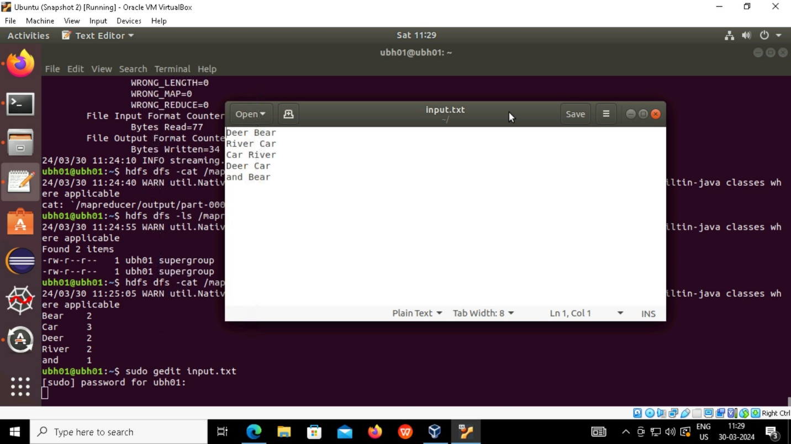

* First create the file by using command **sudo gedit** **input.txt** file by adding some text as shown like above picture.

* Create another file by using command **sudo gedit** **mapper.py** and written some mapper function code inside that file

* Create another file by using command **sudo gedit** **reducer.py** and written some reducer function code inside that file

* By usind command **cat input.txt | python mapper.py** and check whether mapper function is working on the given text file in local
* By using command **cat input.txt | python mapper.py | sort | python reducer.py** and checking whether the mapper and reducer functions are working on the given text file in local.

* By using this command **hdfs dfs -mkdir /mapreducer** create a directory in hdfs
* By using this command **hdfs dsf -put input.txt /mapreducer** moving the file input.txt from local to mapreducer directory in hadoop.

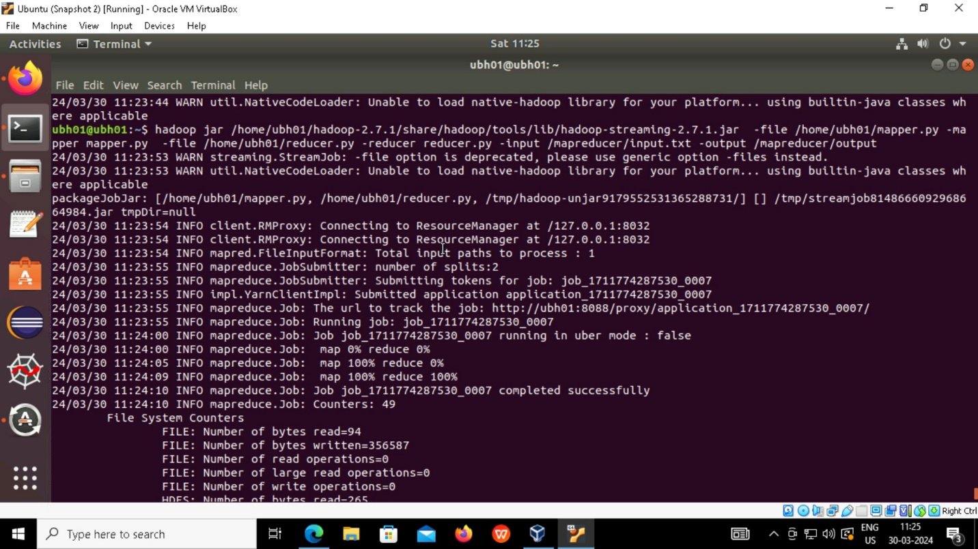

* By using this command
* **hadoop jar /home/ubh01/hadoop-2.7.1/share/hadoop/tools/lib/hadoop/streaming-2.7.1.jar -file /home/ubh01/mapper.py -mapper mapper.py -file /home/ubh01/reducer.py -reducer reducer.py -input /mapreducer/input.txt -output /mapreducer/output**

we are running mapreducer job by using hadoop streaming-2.7.1.jar and checking whether mapper and reducer are working 100% on the given input.txt file.

* After running map reducer job output get succeed and output file given by map reducer is stored in hadoop mapreducer/output directory.

* By using this command **hdfs dfs -ls /mapreducer/output** we are checking whether the output file s given by mapreducer is stored in output directory or not in hadoop
* By using this command **hdfs -cat /mapreducer/output/part-0000** we are checking the output which is given by the mapreducer is correct comparing with the local output